Measurement and verification report

Comparison of GRAS Pinnae:

KB0065 (standard) &

KB5000 (anthropometric)

February 2019

Introduction
In this report, the KB0065 KEMAR Right Pinna 55 Shore 00 is compared with the KB5000 Large Right Anthropometric Pinna 35 Shore 00 (both shown in Figure 1). The KB0065 pinna is used with an ear canal extension (GR0917) in stainless steel. Frequency responses have been measured using GRAS 43AG Ear and Cheek Simulator.
A customer has observed unexpectedly large differences in frequency responses between the two pinnae. Therefore, measurements have been done to verify possible differences between the pinnae.

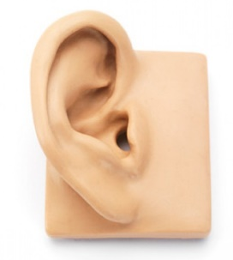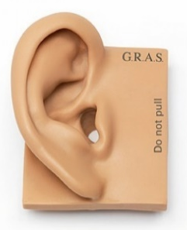
Figure 1: KB0065 KEMAR Right Pinna (55 Shore 00) and KB5000 Large Right Anthropometric Pinna (35 Shore 00).

Method
Two circumaural headphones (Sennheiser HD 380 Pro and Bose QC35-II) and an in-ear earphone (Sennheiser CX2.00i) were tested on GRAS 43AG with a GRAS RA0402 Hi-Res Ear Simulator using two types of pinnae KB0065 (standard) and KB5000 (anthropometric). LabView software, NI USB-4431 and Powerplay Pro-XL 4-channel amplifier were used for data acquisition. Ear Simulator was calibrated using a GRAS 42AB calibrator which emits a pure tone with a frequency of 1 kHz and level of 114 dB SPL. Noise cancellation was turned off on the Bose headphone. An application force of 7N (where 8 N is the maximal force applied with one spring) was applied. Ten measurements were done. Headphone was re-positioned each time. See Figure 2 for pictures of the measurement setups.
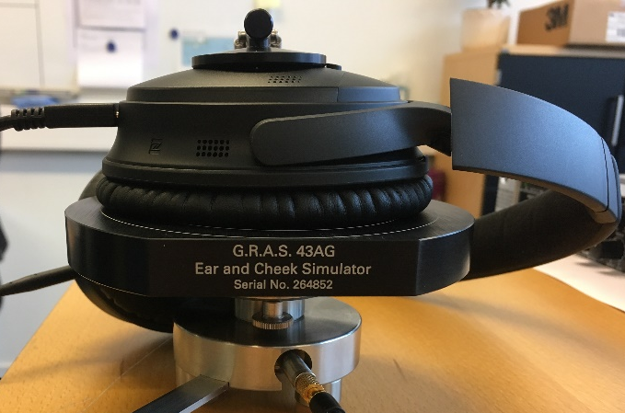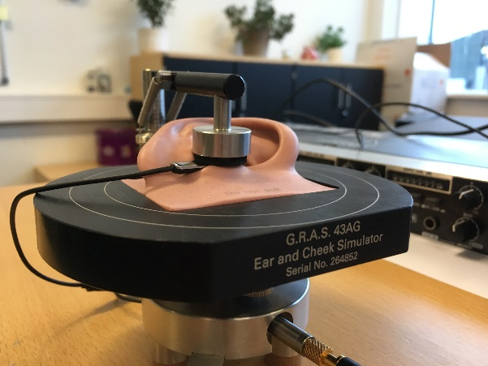
Figure 2: Pictures of measurement setups (43AG with clamp) – with Bose QC35-II headphone (left) and Sennheiser CX2.00i in-ear (right).

Results
The means and the confidence intervals (95%) are shown. The GRAS measurement results are shown in Figure 3 to Figure 5. For the comparison, the customer’s data is shown in Fig. 6, though without confidence intervals – however, these were found to be rather small.

Figure 3: Frequency responses of Bose QC35-II ANC-headphone (where ANC was turned off) for two pinnae, KB0065 and KB5000 using GRAS 43AG.
Figure 4: Frequency response of Sennheiser HD380 Pro for two pinnae, KB0065 and KB5000 using GRAS 43AG.

Figure 5: Frequency response of in ear Sennheiser CX2.00i earphone for two pinnae, KB0065 and KB5000 using GRAS 43AG.

Figure 6: Frequency response measured by the customer using a Focal Elegia headphone and a measurement setup with pinna (KB0065 and KB5000) and ear simulator mounted in MDF-plates.

Discussion and conclusions
As seen in the results, there are differences between the frequency responses obtained with KB0065 and KB5000 (anthropometric). The differences between the pinnae can be discussed in terms of the ear canal resonances and shapes. It is observed that the resonance frequency frequencies are slightly increased when shifting from KB0065 to KB5000, but the general tendencies in the responses are similar. For example, the KB5000 is softer and more similar to the human pinna. This plays a role when trying to obtain a good coupling/seal between the headphone and the pinna on the GRAS 43AG.
Therefore, it raises the question why the customer has differences of up to 15 dB in the frequency range around 6.5 kHz between the two pinnae. This seems like a huge difference which we have not been able to reproduce in our measurements.
There are important factors that play a role in the measurement and verification of the influence of the pinna, hence the application force and sealing provided to the headphone under test. The measurement setups used by GRAS and the customer are different and maybe this can explain some of the variation seen.
As seen in Figure 7, the HRTF (Head related transfer function) can be divided into subcomponents explaining the characteristics of the transfer function. For example, the ear canal plays a significant role in the frequency areas around 2.5 kHz and 7 kHz where length resonances dominate the transfer function. A slight change in the measurement plane of the headphone can thereby change the ear canal acoustics and thereby the measured frequency response of the headphone. Therefore, a smaller confidence interval is obtained with the in-ear headphone because the pinna and the sealing are by-passed. However, the insertion of the earphone (and thereby the measurement plane) will cause a change in the measured resonance frequency.

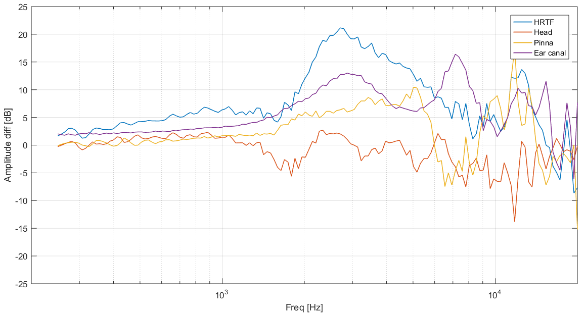
Figure 7: The influence of subcomponents (head, pinna and ear canal) on the measured HRTF of KEMAR.

